1.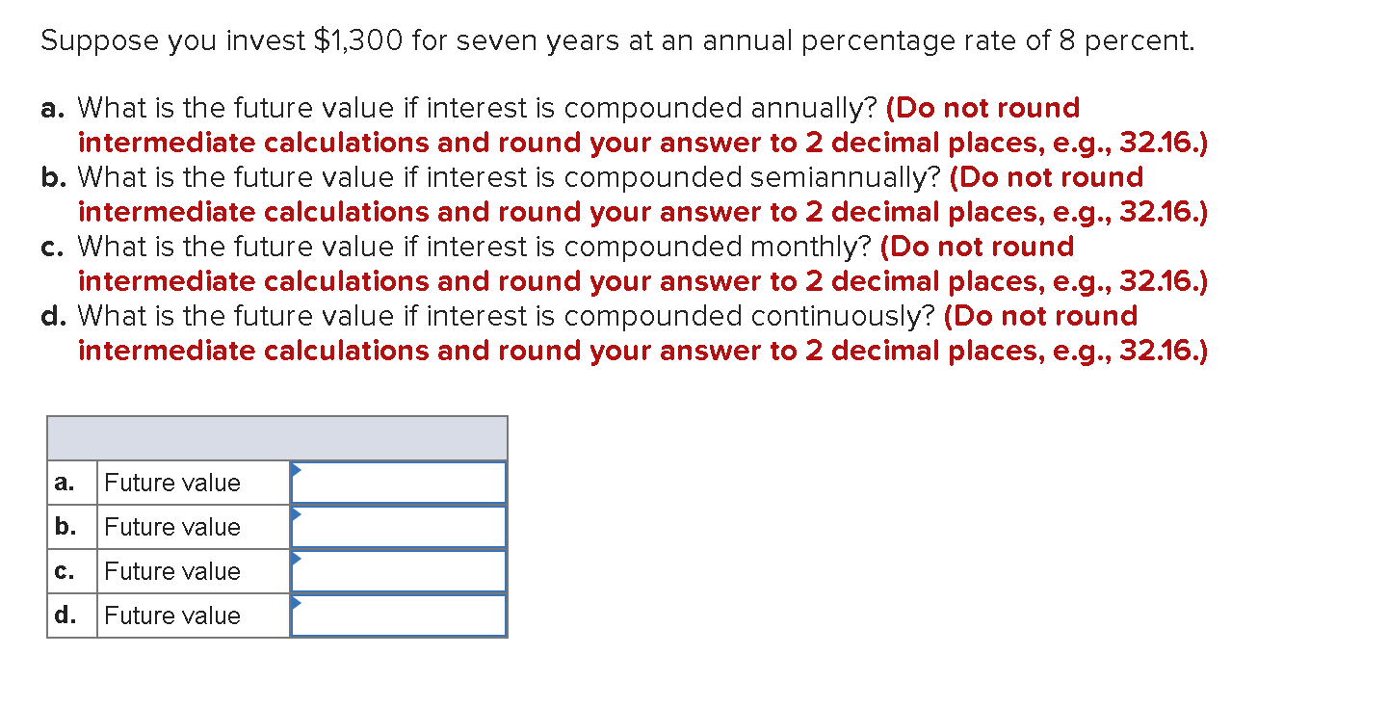
a) PV = 1300, n=7, r=8%
FV = P*(1+0.08)⁷
= $2,227.97
b) PV=1300, n= 14, r=4%
FV =1300*(1+0.04)¹⁴
= $2,251.18
c) PV = 1300, n=84, r=0.6667%
FV =1300*(1+2/3)⁸⁴
= $2,271.65
d) FV = PV x (e ^{i*n})
=1300* (e ^{(0.08*7)})
= $2,275.87

2.
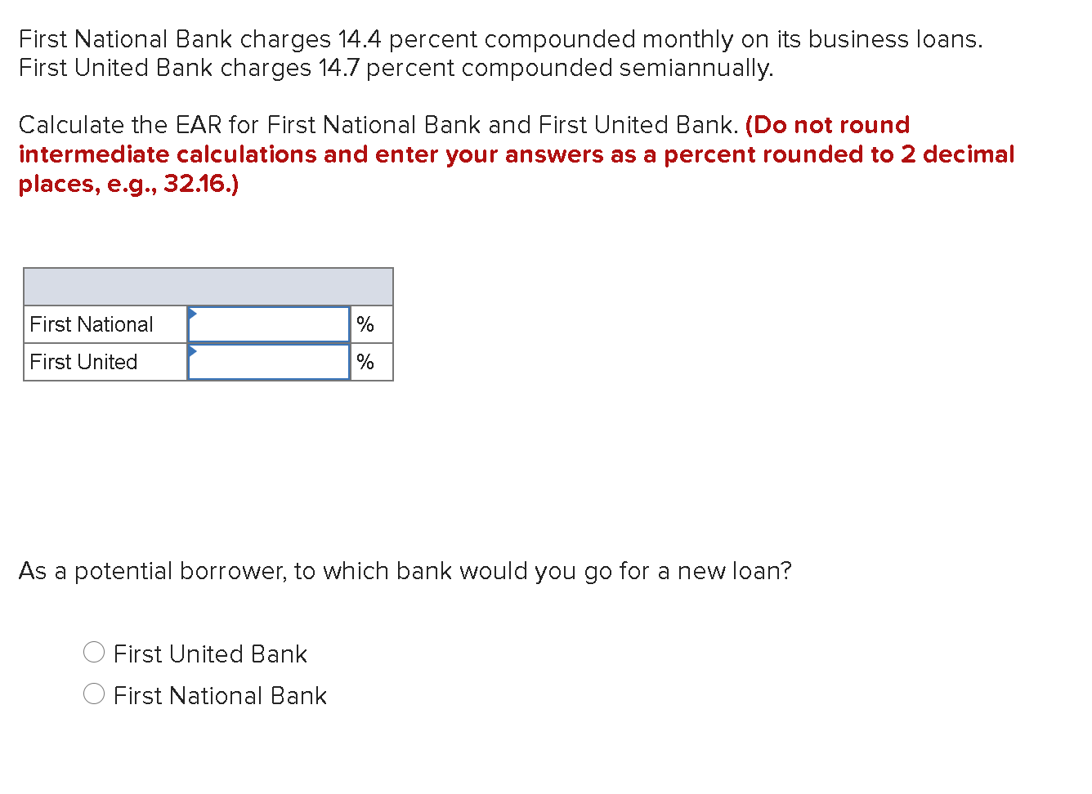

For National bank
EAR = (1+0.144/12) ⁽¹²⁾ -1
= 15.39%
For First United Bank
EAR = (1+0.147/2) ⁽²⁾ -1
= 15.24%
He should loan from First United Bank since it has a lesser effective annual rate

3.
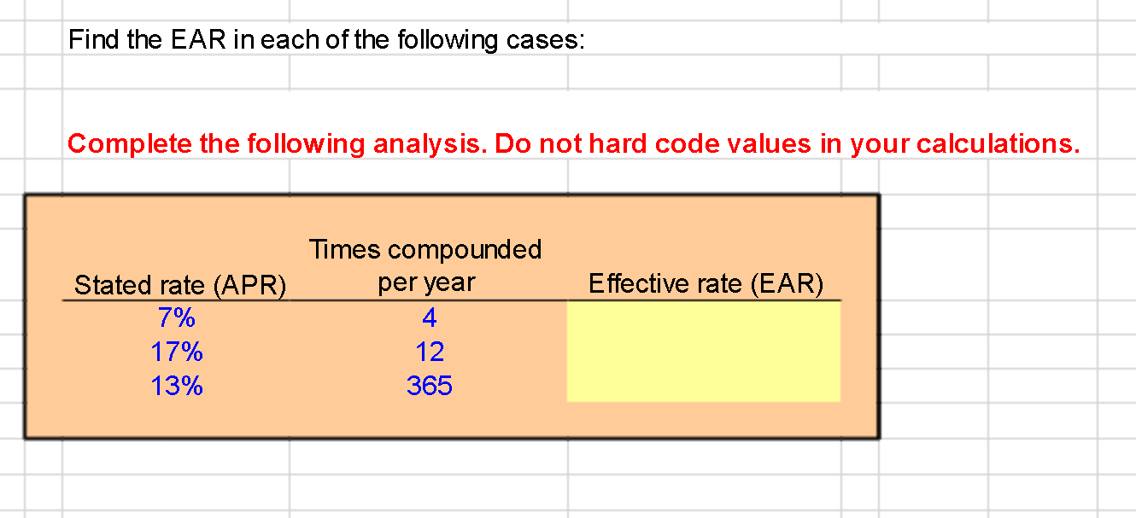

i) 7%
EAR = (1+0.07/4) ⁽⁴⁾ -1
= 7.19%
ii) 17%
EAR = (1+0.17/12) ⁽¹²⁾ -1
= 18.39%
iii) 13%
EAR = (1+0.13/365) (365) -1
= 13.88%

4.

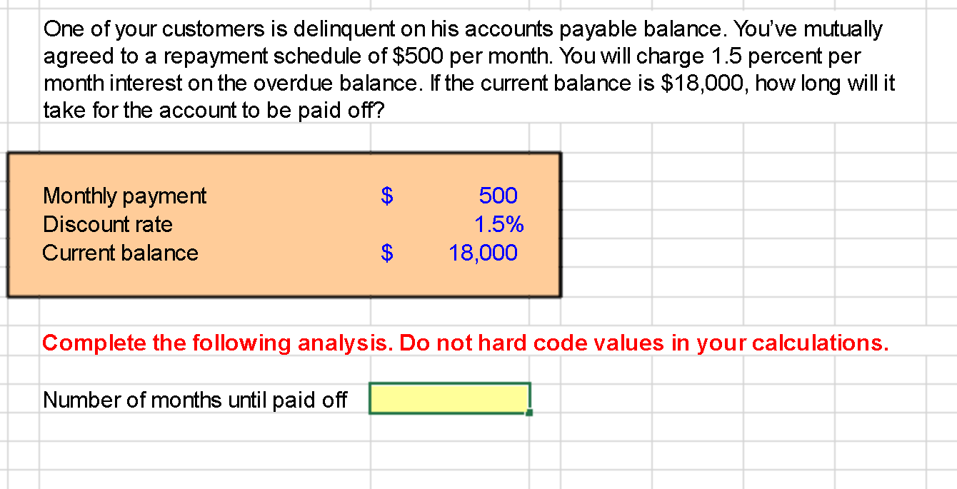

36.85 months

5.
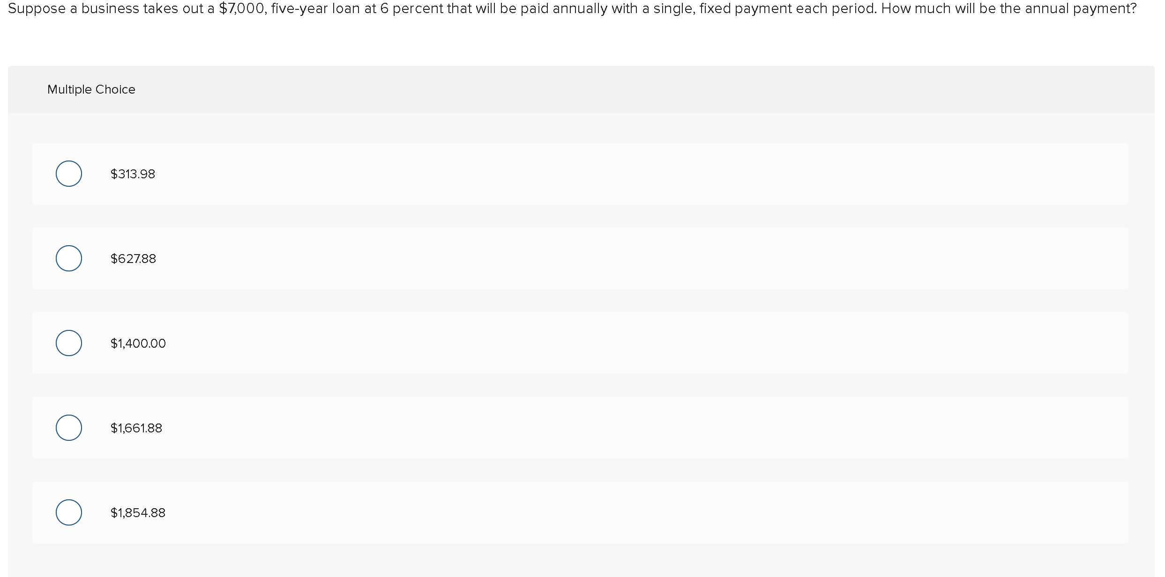
PMT = PV/ PVIFA _{k,n}
= 7000/ 4.2123
=$1,661.88

6. 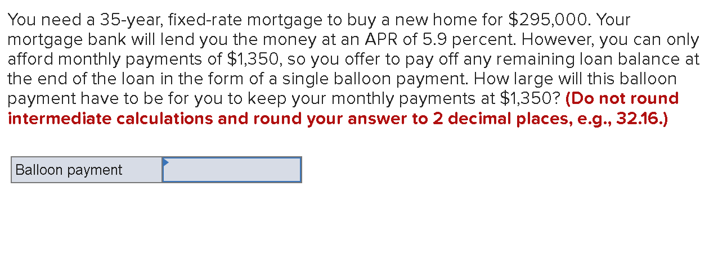
PMT = 1350, r =5.9/12%
1350 = PV/PVIFA
PV =1350*PVIFA
=1350* 34.6921
=$46,834.335

7.
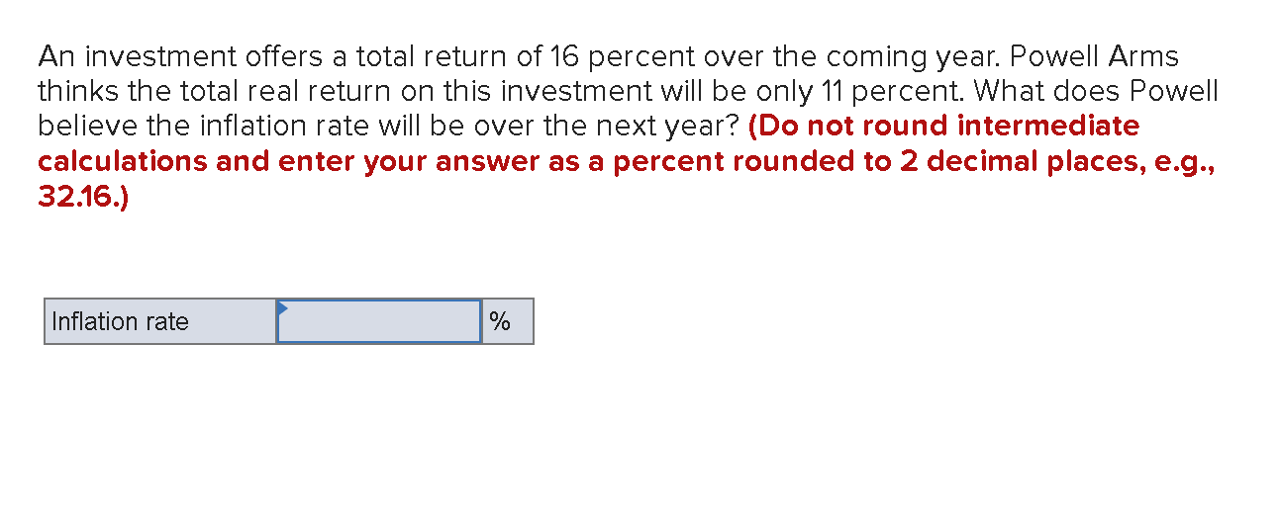
Inflation adjusted return = 1+return -1
1+inflation rate
0.11 = (1+0.16/1+i)-1
Inlation rate = 4.505%

8.
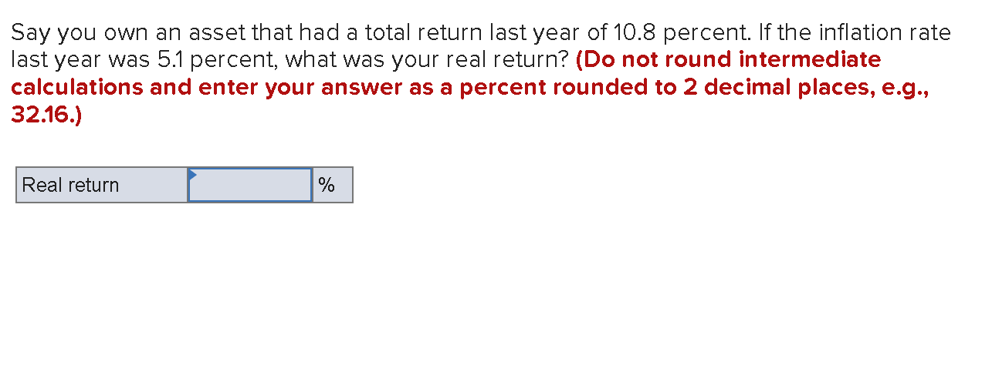
Inflation adjusted return = 1+return -1
1+inflation rate
= (1.108/1.051) – 1
= 5.423%

9.
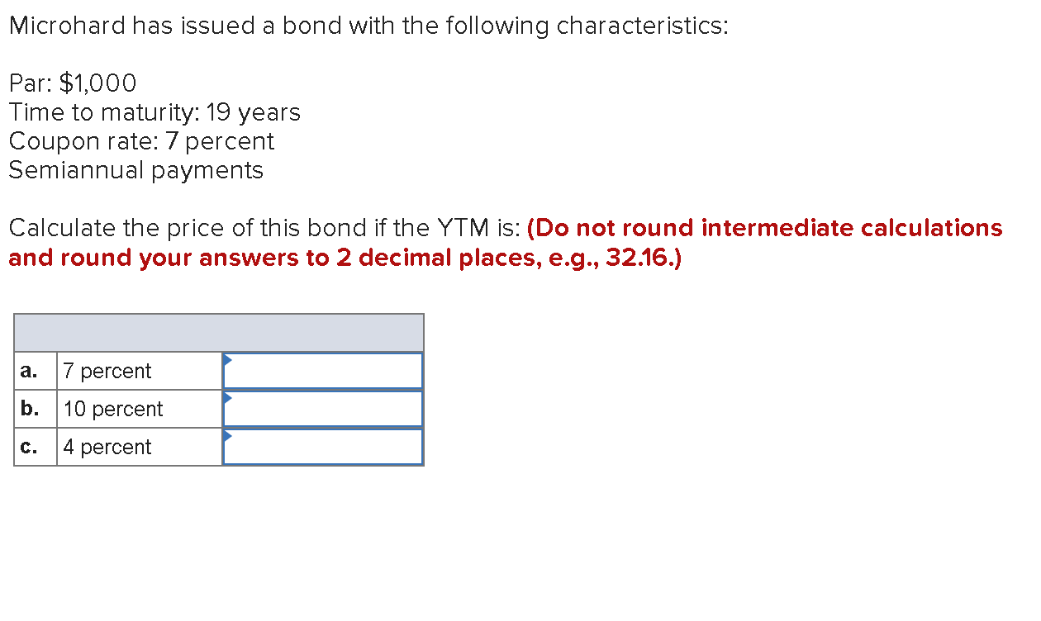

YTM | Interest | PVIFA | Face value | PVIF | Price
7% | 35 | 20.8411 | 1000 | 0.2706 | 1000.0385
10% | 35 | 16.8679 | 1000 | 0.1566 | 746.9765
4% | 35 | 26.4406 | 1000 | 0.4712 | 1396.621

10. 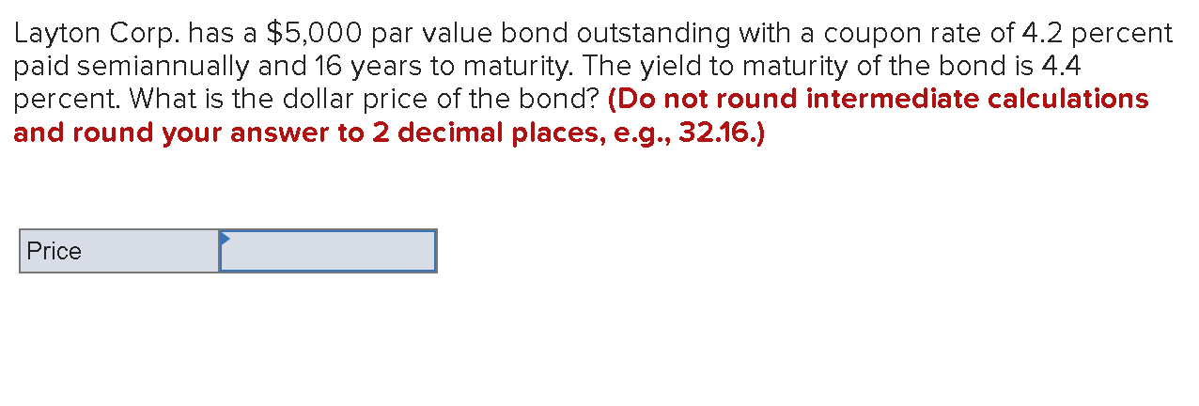
Interest per period = 4.2%/2*5000
= 105
Price of the bond = 105*PVIFA + 5000*PVIF
= 105*22.8003 +5000*0.4984
= $4,886.0315
11. 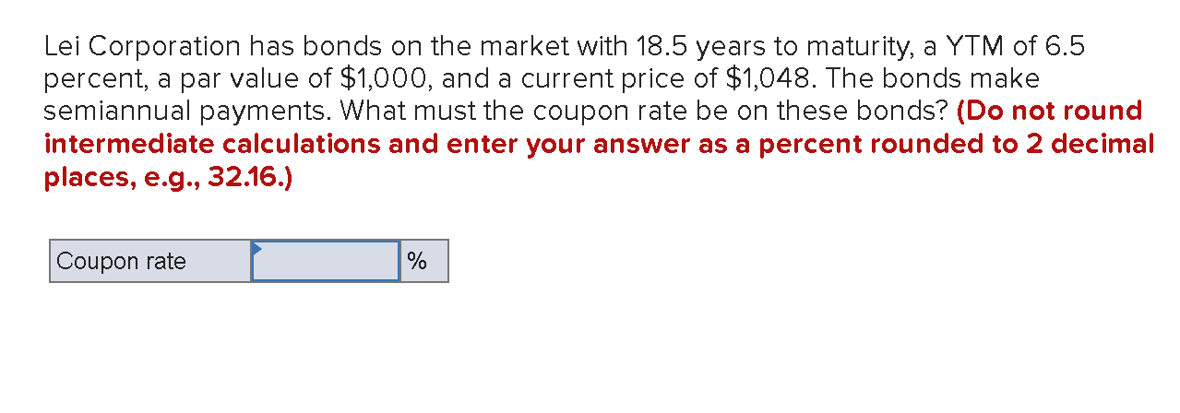
1048= (Intrest*PVIFA +1000*PVIF)
1048 = interest *21.3463 + 1000*0.3062
21.3463 interest =1048+306.2441
Interest = 63.4416
Coupon rate = 63.4416/1000
=6.34%

12. 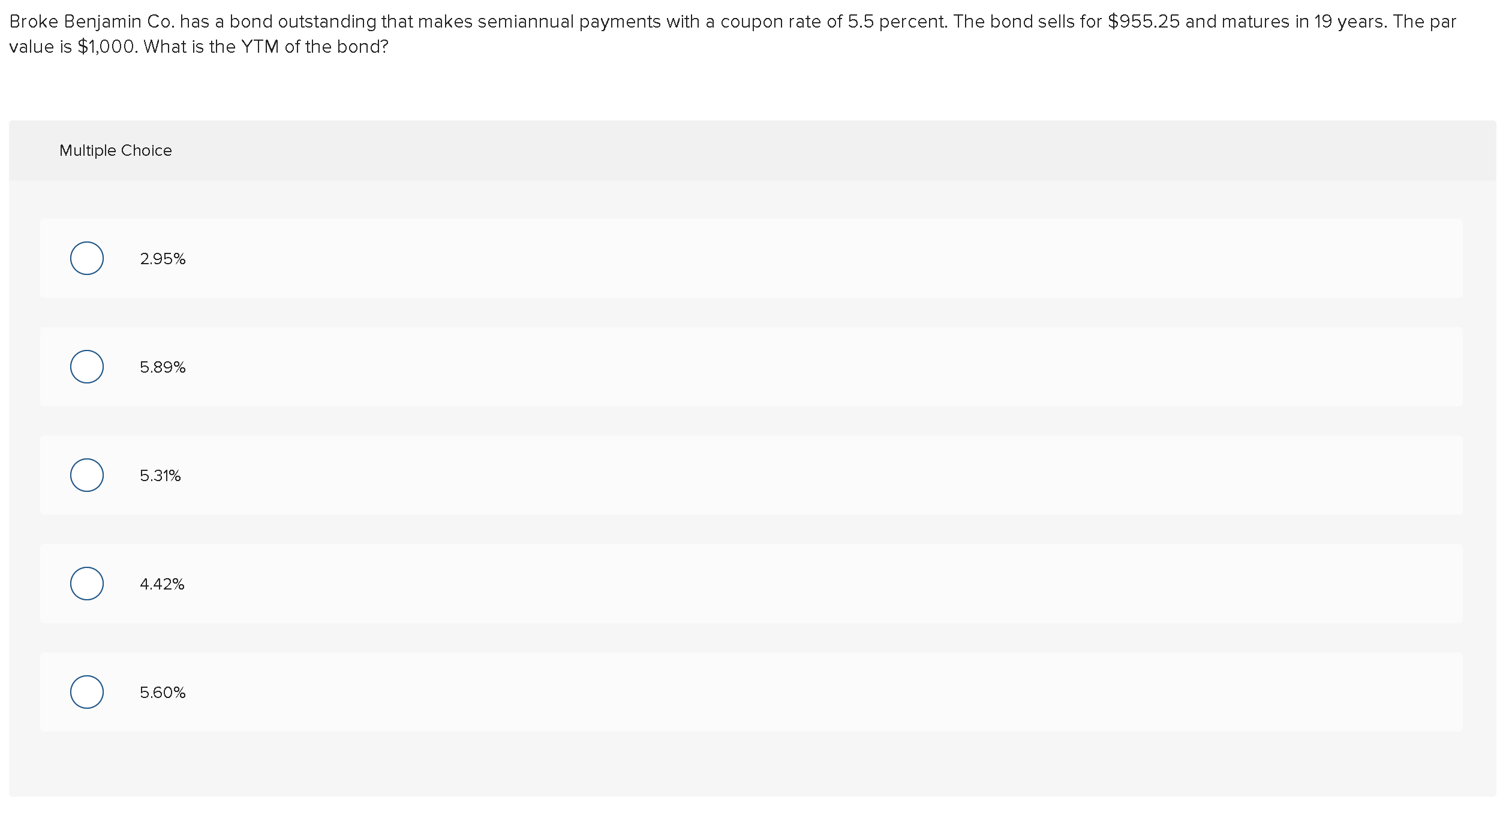
955.25 = (55*PVIFA +1000*PVIF)
Therefore, YTM is the rate used to get PVIFA and PVIF
YTM = 5.89%

13. 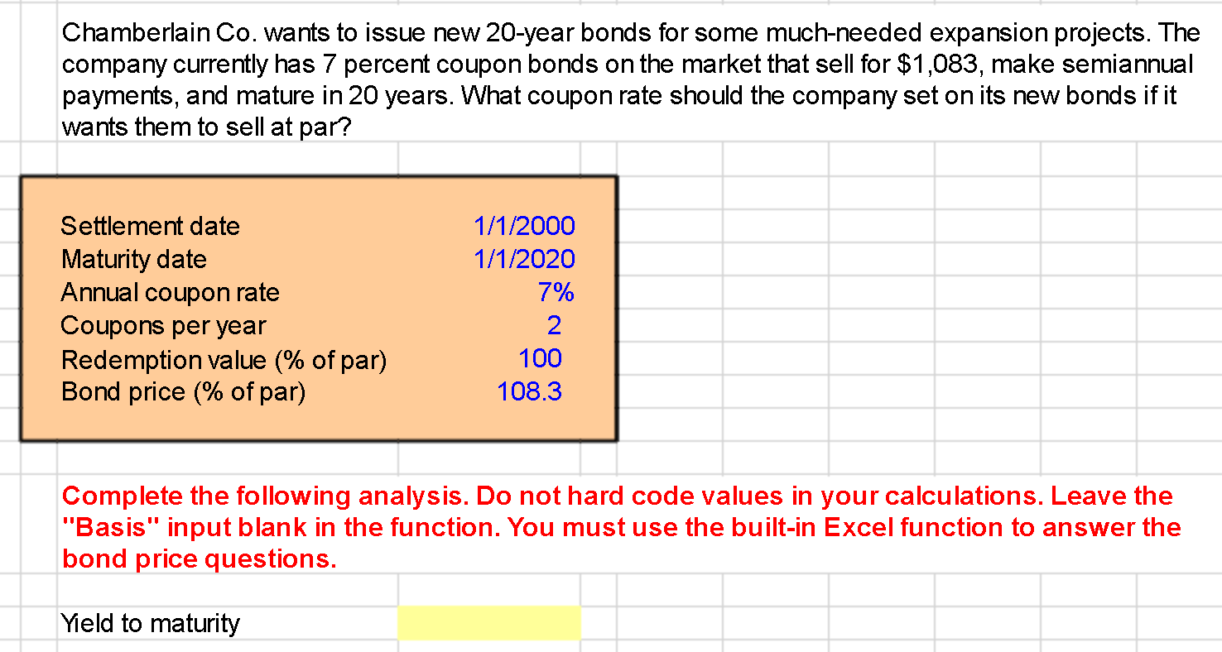
YTM = (35+(1000-1083)/40)
2083/2
= 3.16%
1000 = Interest *PVIFA + 1000*PVIF
1000 =Interet * 22.5284+1000* 0.2881
Interest = 1288.1/22.5284
=$57.1767
Coupon rate for it to sell at par = 57.1767/1000
= 5.717%

